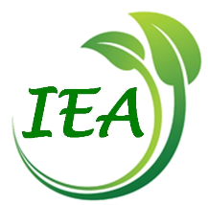
Certificate

Email the completed form to the Membership Officer, IEA: membership@ecoling.net

Please fill out this form to apply for a certificate of successful completion for The Stories We Live By: an online course in Ecolinguistics. To receive a certificate, you will need to state that you have worked through the nine parts of the course and complete a short reflection on the impact of ecolinguistics on your life or work (about 500 words). The form can be completed in any language.

Your name:

Your email:

Your occupation:

Yes/No
I have worked through the nine parts of the course:

Please say a little about yourself, e.g., what you research or study or about your work:

Please describe the impact that taking this course (and reading other material by Arran Stibbe) has had on your work or life, in around 500 words.

When you have competed the sections above, please email the form to the Membership Officer at the International Ecolinguistics Association: membership@ecoling.net

I give permission for extracts from this form to be published anonymously to demonstrate the impact that the course has had. Change to ‘no’ if you do not agree to this.
Yes

Notes

- This online course is funded by the University of Gloucestershire and run in conjunction with the International Ecolinguistics Association. The certificate of successful completion is offered by the International Ecolinguistics Association and does not carry academic credit.

